**JAYPEE INSTITUTE OF INFORMATION AND TECHNOLOGY, NOIDA**

**DEPARTMENT OF COMPUTER SCIENCE AND ENGINEERING**

**Semester-III (ODD-2024)**

**DATABASE AND WEB LAB**



**PROJECT REPORT**

**GROCERY SHOPPING PLATFORM**

**SUBMITTED TO: - SUBMITTED BY: -**

**Mrs. Kirti Jain** **SAMBHAV MISHRA [23103398]**

**Mrs. Aarti Goel**  **MOHD. HAYAT AZEEM [23103382]**

**HARSHVARDHAN TIWARI [23103394]**

**ANSHUMAN SINGH [23103399]**

**Table of Contents**

* **Title Page**
* **Table of Contents**
* **Introduction**
* **Project Overview**
* **Technology stack**
* **Key Features**
* **ER Diagram**
* **Conclusion**
* **References**

**Introduction**

The Grocery Shopping Platform is a modern, web-based application designed to revolutionize the way consumers purchase their groceries. With the rise of e-commerce and the increasing demand for convenience in everyday tasks, this platform aims to provide users with a seamless and engaging shopping experience for purchasing groceries online. It combines essential e-commerce functionalities with innovative features, such as recipe suggestions and pantry management, to enhance the overall shopping experience.

In today’s fast-paced world, more consumers are turning to online shopping for their grocery needs. Traditional grocery shopping can be time-consuming and often requires users to visit physical stores, compare prices, and hunt for specific items. The Grocery Shopping Platform addresses these pain points by providing a user-friendly interface that allows customers to browse, select, and purchase groceries with ease—without leaving the comfort of their home.

The Grocery Shopping Platform is a web-based application developed to provide users with an easy and convenient way to browse and purchase groceries online. The platform aims to simplify the process of grocery shopping, offering various features like product browsing, a shopping cart, recipe suggestions, pantry management, and more. This system was developed using a combination of web technologies including HTML, CSS, JavaScript, PHP, and SQL.

This report outlines the development process, features, and the technological stack used in the creation of the platform. The system's primary goal is to enhance the online grocery shopping experience by providing a user-friendly, seamless, and interactive interface.

**Project Overview**

The platform aims to help users find and buy groceries with ease while also managing their pantry and getting recipe suggestions based on available ingredients. Key features include:

* **Homepage**: Displays a variety of grocery categories and popular products for easy browsing.
* **Product Cart**: Users can add and manage items they intend to purchase.
* **Recipe Suggestions**: The platform suggests recipes based on the items in the user’s pantry or shopping cart.
* **Pantry Management**: Users can track and manage the groceries they currently have at home
* **Sign-Up Page**

We have developed a sign-up page for new registrations of new customers to save their data and suggest them products accordingly.

* **Log-In Page**

We created a log-in page so that old customers can retrieve their old data and product history making it easier to navigate and suggest items.

**Technology Stack**

The platform uses the following technologies:

**Frontend**

* **HTML**: Used for creating the structure and layout of the platform’s pages.
* **CSS**: Used for styling the platform’s web pages to create an aesthetically pleasing and user-friendly interface.
* **JavaScript**: Implemented to add interactivity and dynamic content such as updating the cart in real time and fetching product details asynchronously.

**Backend**

* **PHP**: Used as the server-side language to handle form submissions, user authentication, session management, and communication with the database.
* **SQL (MySQL)**: Used for managing the database, storing product data, user information, and transaction details. The database allows the platform to maintain inventory and order history efficiently.

**Additional Tools & Libraries**

* **Bootstrap**: Used for responsive design to ensure the platform works well on both desktops and mobile devices.

**Key Features**

* **Homepage**

The homepage of the platform provides an organized view of grocery categories, top-selling products, and promotional items. Users can easily browse products, view product details, and search for specific items.

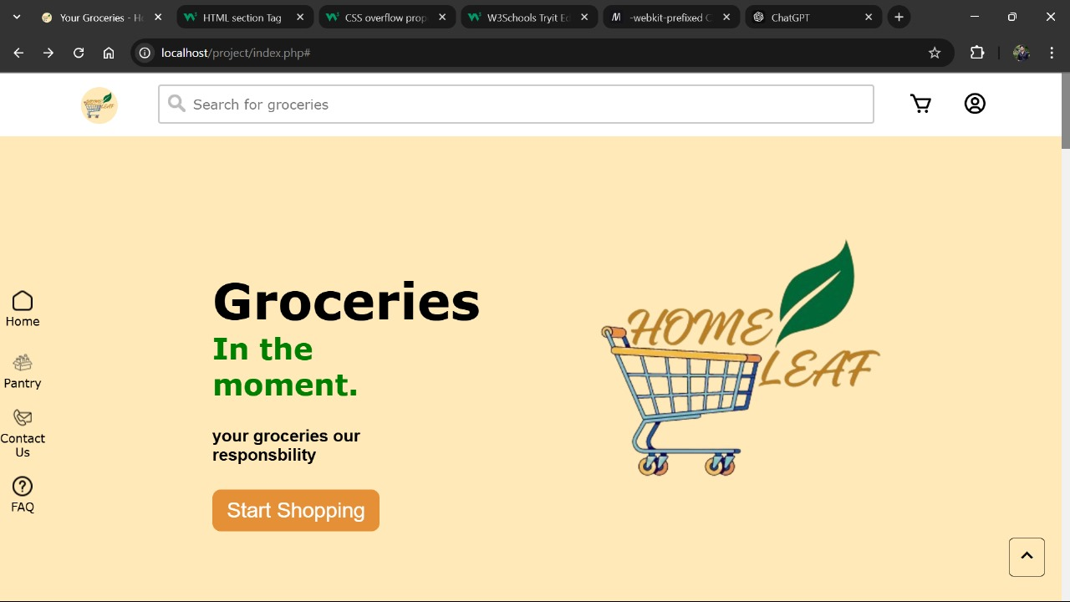

* **Product Catalog**

Users can browse products based on categories such as fruits, vegetables, dairy, etc. Products are displayed with essential details like price, image, and description.

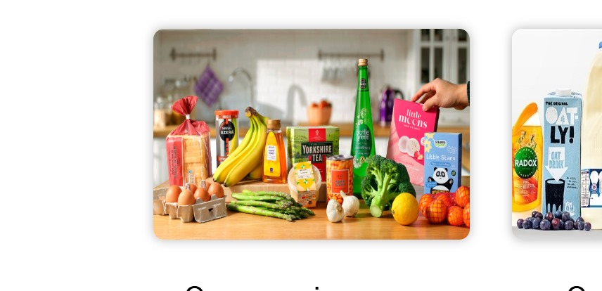

* **Shopping Cart**

The shopping cart allows users to add products, remove them, and update quantities. The cart automatically updates the total price based on the selected items. The cart is stored in the user’s session or database, ensuring a consistent shopping experience.

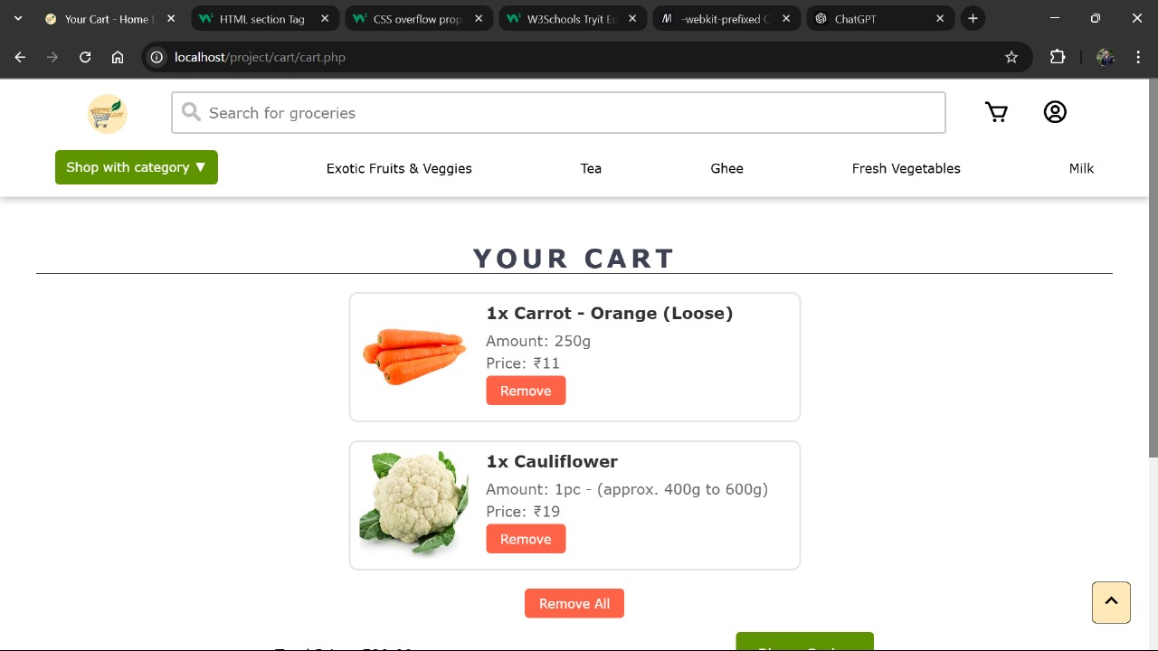

* **Recipe Suggestions**

The platform suggests recipes based on the ingredients the user adds to their shopping cart or pantry. The suggestions are dynamically generated based on the ingredients the user already has or intends to buy.

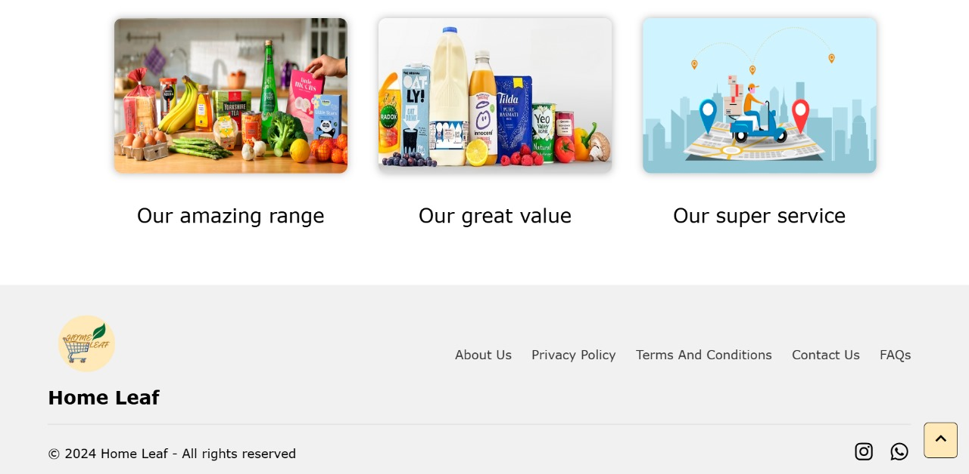

* **Pantry Management**

Users can add items they currently have at home to their pantry, track stock levels, and even receive suggestions on what to buy based on missing ingredients for recipes.

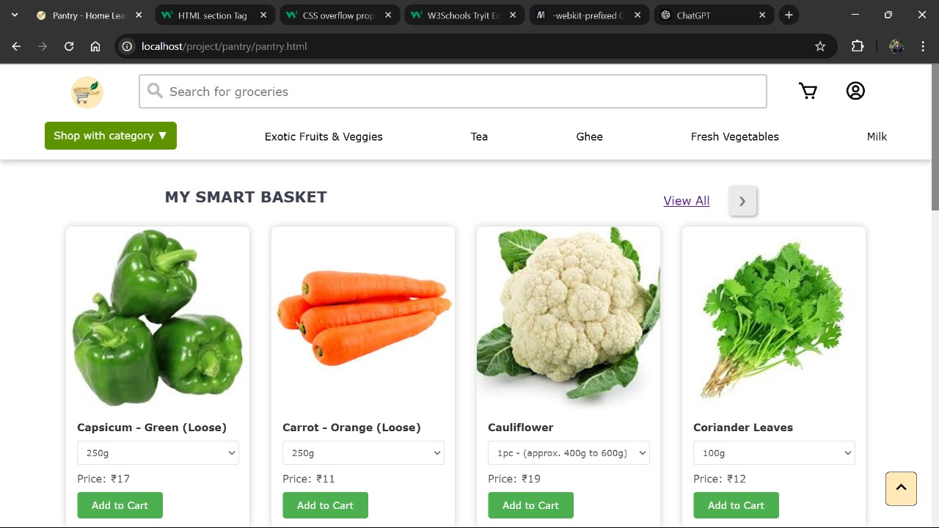

* **Search and Filter**

A search bar is available to allow users to quickly find products.



* **FAQ**

We have a special section for our customers to clear their recently asked questions and queries.

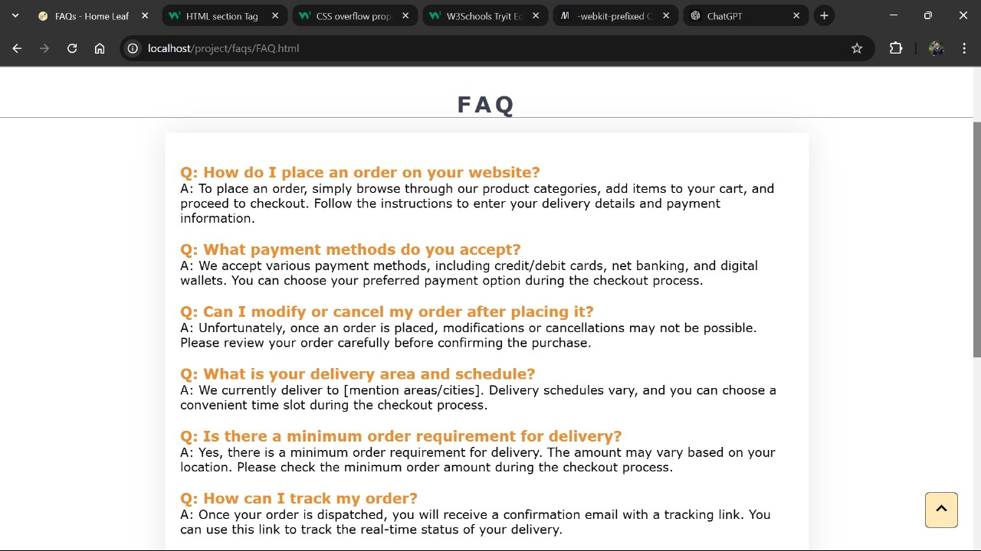

* **Sign-Up Page**

We have developed a sign-up page for new registrations of new customers to save their data and suggest them products accordingly.

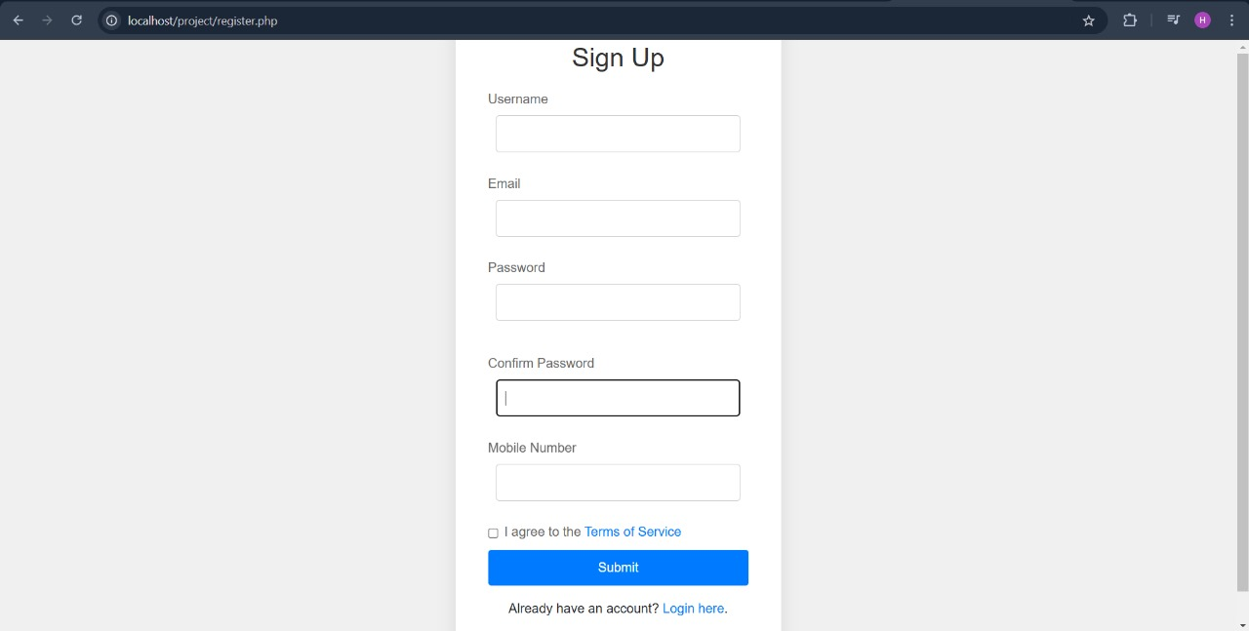

* **Log-In Page**

We created a log-in page so that old customers can retrieve their old data and product history making it easier to navigate and suggest items.

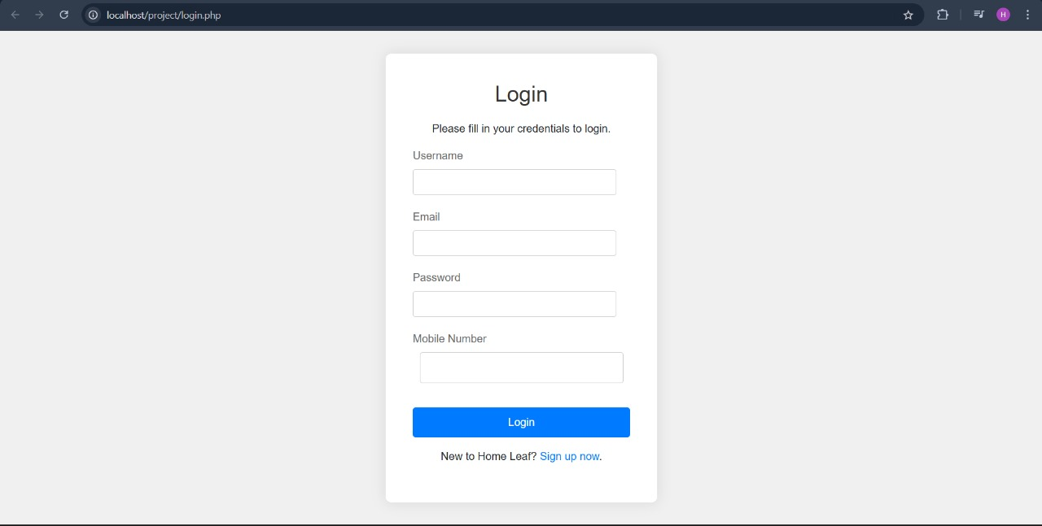

* **Contact Us**

We have created a contact us page so that the user can easily contact the customer services in times of need via email.

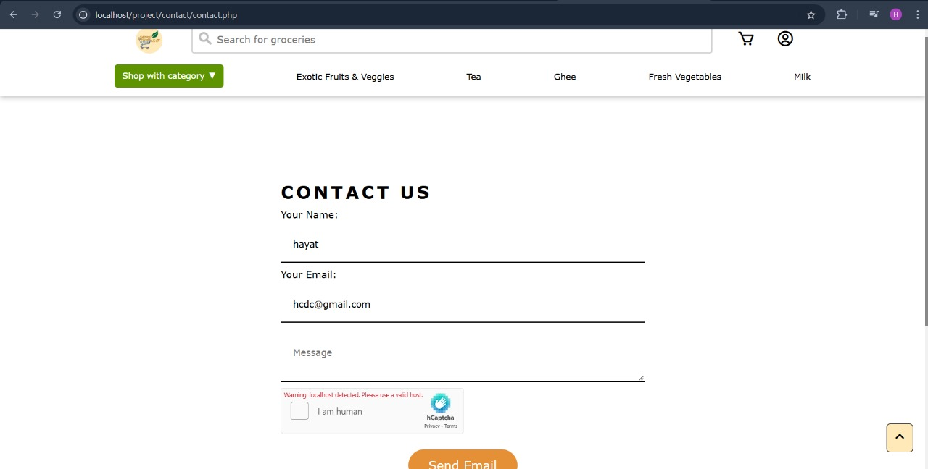

* **Terms and Agreement**

We have created a terms and agreement page so that the user can easily read all our policies with full transparency.

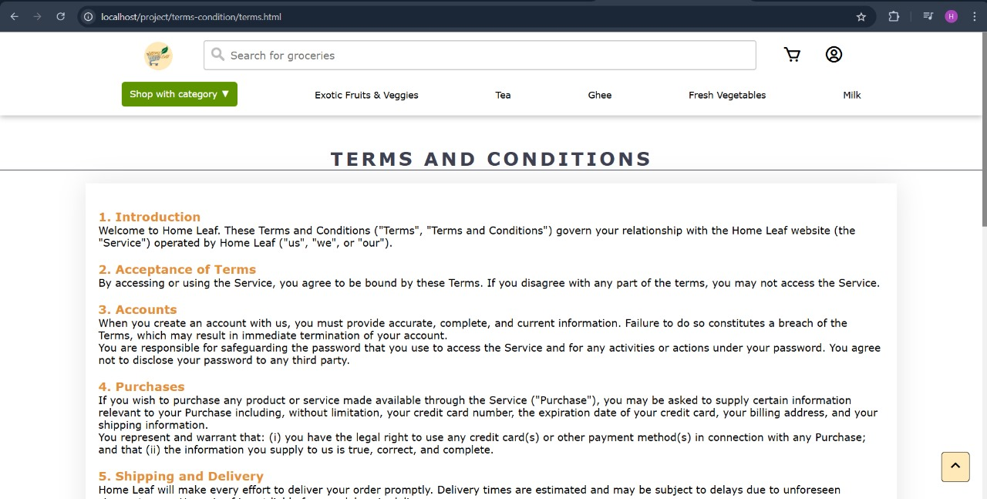

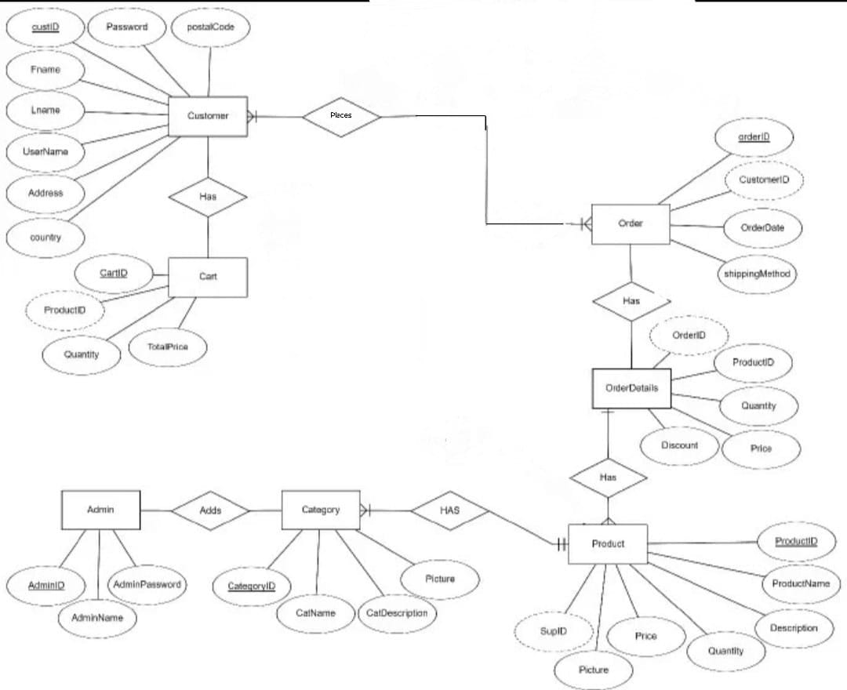

**Conclusion**

The Grocery Shopping Platform represents a significant step forward in the evolution of online grocery shopping, providing a comprehensive solution that goes beyond simply offering a marketplace for products. By integrating innovative features like recipe suggestions, pantry management, and a personalized shopping experience, the platform addresses the real-world needs of today’s busy consumers.

Throughout its development, the project has focused on creating an intuitive, user-friendly interface while ensuring the underlying architecture is scalable, secure, and able to handle a growing number of users and products. The combination of frontend technologies such as HTML, CSS, and JavaScript, alongside backend tools like PHP and MySQL, has created a robust platform that not only meets functional requirements but also offers an engaging and seamless experience for users.

One of the standout features of the platform is its personalization capabilities. The pantry management system, for instance, helps users keep track of what they already have at home, enabling them to shop smarter and reduce food waste. The recipe suggestion feature adds another layer of personalization by recommending meals based on the items available in the user’s cart or pantry, which makes the platform more than just a shopping tool—it becomes an assistant that helps users make better decisions for their meals and shopping habits.

Additionally, the secure checkout system ensures that users can shop with confidence, knowing that their personal and payment details are protected. The platform also allows for efficient and real-time updates to the shopping cart, making the process of browsing, adding items, and completing purchases smooth and quick.

**REFERENCES :-**

**1. Boxicons (Icon Library):**

* [**Boxicons Official Website**](https://boxicons.com/)
* **Boxicons Documentation**

**2. MDN Web Docs:**

* [**MDN Web Docs - CSS**](https://developer.mozilla.org/en-US/docs/Web/CSS)
* [**MDN Web Docs - JavaScript**](https://developer.mozilla.org/en-US/docs/Web/JavaScript)
* [**MDN Web Docs - HTML**](https://developer.mozilla.org/en-US/docs/Web/HTML)
* [**MDN Web Docs - DOM**](https://developer.mozilla.org/en-US/docs/Web/API/Document_Object_Model)

**3. W3Schools:**

* **W3Schools - CSS**
* **W3Schools - JavaScript**
* **W3Schools - HTML**
* **W3Schools - CSS Flexbox**

**4. GeeksforGeeks:**

* **GeeksforGeeks - CSS Tutorials**
* **GeeksforGeeks - JavaScript Tutorials**
* **GeeksforGeeks - HTML Tutorials**
* **GeeksforGeeks - DOM Manipulation**